KOWTHA & CO.,
CHARTERED ACCOUNTANTS 9490008968 (AP)
Flat No. 501, AB Heights, Prem Nagar Colony 8330961359 (TS)
Road No. 1, Banjara Hills, Hyderabad-500 033 Mail ID: kowthaTS@gmail.com
PERSONAL DISCUSSION SHEET

NAME OF THE APPLICANT | Mr. XXX
INTERVIEWED BY | Mr. XX
PERSON CONTACTED | Mr. XXX
DATE | 17-05-2025.
LOAN AMOUNT REQUEST | Rs. 85,00,000/-
PLACE OF INTERVIEW | APPLICANT’S BUSINESS PLACE
CONTACT NUMBER | XXX

PERSONAL DETAILS
FAMILY BACK GROUND
Name | Relation |  | Age | Education | Occupation
XX | Wife |  | 45yrs | - | -
XX | Son |  | 22yrs | - | -
XX | Son |  | 20yrs | Inter | -
XX | Son |  | 18yrs | 10th class | -
NO. OF. DEPENDANTS |  | 05
GENERAL LIFESTYLE/PERSONALITY |  | Good

PLACE OF RESIDENCE/OFFICE
CURRENT ADDRESS DETAILS: | H No: XXXXX
OWNERSHIP AND NAME OF OWNERS | Own
COLLATERAL DESCRIPTION and TYPE | Own House property
OFFICE PREMISES DETAILS | XXX
OWNERSHIP AND NAME OF OWNERS / NA for Salaried | Rented

COMPANY PROFILE.

- Applicant started business in 2010
- He is running business under the name of M/S. XXX at XXX.
- The applicant is the proprietor of this business and he manages the all business activity.
- Nature of the business is dress coloring and dry cleaning works.
- He is doing all types of sarees coloring, design printing and dry cleaning works etc.
- He charges Rs. 450 to Rs. 800 for sarees coloring, Rs. 600 to Rs. 800 for saree design printing works and Rs. 150 to Rs. 200 for dry cleaning works etc.
- The customers are general people.
- He purchases colour and other materials from Hyderabad.
- He is running business from owned premises.
- There are 05 employees are working under the business and he pays Rs. 70,000 per month.
- Major business transactions are done through cash/bank in her business.
- UPI scanners are seen in the business premises and registered with applicant name.

SELF EMPLOYED / SALARIED

NAME OF BUSINESS / EMPLOYMENT | M/S. XXX
NATURE OF BUSINESS ENTITY / EMPLOYER DETAILS in case of Salaried | PROPRIETORY PARTNERSHIP PVT. LTD  
Key Manager to the business | Mr. XXX
No of years in business / Employment | 15 Years.
Type of Business | Dress coloring and dry cleaning works

BUSINESS DETAILS
MAIN CLIENTS | General public and builders
EMPLOYEE / OTHER MAJOR COST | No of employees: 05 Total Salaries per month: - Rs. 70,000/-
EMPLOYEE / OTHER MAJOR COST | Accounting year | Estimated (Rs.) 31.03.22 (Rs.)
BUSINESS DATA
  Annual Sales | Rs. 24,00,000/- | -
  Overall costs | Rs. 16,32,000/- | -
  Major cost heads | Purchases, and Transportation | -
  Gross margin % | 80% | -
  PBDIT Margin % | 32% | -
  Debtors cycle | - | -
  Creditors cycle | - | -
  Capital invested | - | -
  Loan funds incl CC limit | - | -
  Stock maintained | - | -
  Business bank accounts | HDFC | -

CO- APPLICANT’S INCOME: Nil

Other Income: -
- NA

LIC PAYMENT/INSURANCE/  MEDICLAIM | Nil
SHARE/MUTUAL FUND INVESTMENTS | Nil
CARS/TW OWNED | -
OTHER PROPERTY’S OWNED | -
OTHER ASSETS like FD,PPF etc | Nil

OTHER LIABILITIES INCLUDING CC LIMITS (OWN/CO APPLICANTS)
FROM | NATURE OF LOAN / ACCOUNT NO. | O/S AMOUNT | EMI | Will close/ continue
Nil | - | - | - | -

BUDGET ANALYSIS:
S.NO | PARTICULARS | AMOUNT
1 | Total Monthly Net Income per month (Business income + Other Income) | Rs. 64,000/-
2 | Overall Family expenses per month, | Rs. 10,000/-
3 | PL / Auto Loan EMI | -
4 | Other Loan EMI | -
 | Total Monthly Expenses per month | Rs. 10,000/-
 | NET SURPLUS | Rs. 54,000/-
 | AFFORDABLE EMI | -

END USE OF FUNDS: Applicant wants to avail this loan for Purchase of Business Development.

Other Observation:
- He provided bank statement
- He provided ITR
- He provided labour license
- He provided ITR

Overall Positives/Negatives: The applicant has been doing this business for 15 years. As per oral information and submitted documents we prepared the estimated financial statement. As per the nature of business the PBDIT Margin is 32%. The business is subject to market conditions and other factors and of course competition.

Trade Reference – Not provided

Sl No | Name of the Person | Telephone No/Address for Communication
1.
2.

Profile is Ok to do

√
ACCEPT/REJECT

SIGNATURE/

NAME: K. Venkatasubba Rao

ESTIMATED INCOME.
M/S. XXXXXX

As per customer the sales turnover will be around Rs. 24 lakhs
Out of the total Gross Receipts, some are cash and some are credit. We have arrived at the estimated profit for the period 31.03.24 basing on previous figures and submissions by the customer.
The PAT of the business concern Rs. 7,68,000/- P.A.

Note: - We have taken the estimated figures based on customer feedback and the gross profit has been calculated taking into consideration market information gathered on our experience.

Disclaimer clause: - The Report (Including any attachments) has been prepared on the basis of verbal information provided by the person contacted.

TATA (Tata housing finance Ltd / Tata capital Ltd., will be solely responsible for any actions taken on this report and any liabilities directly or indirectly accruing from such actions, efficient services will not be liable in any case.

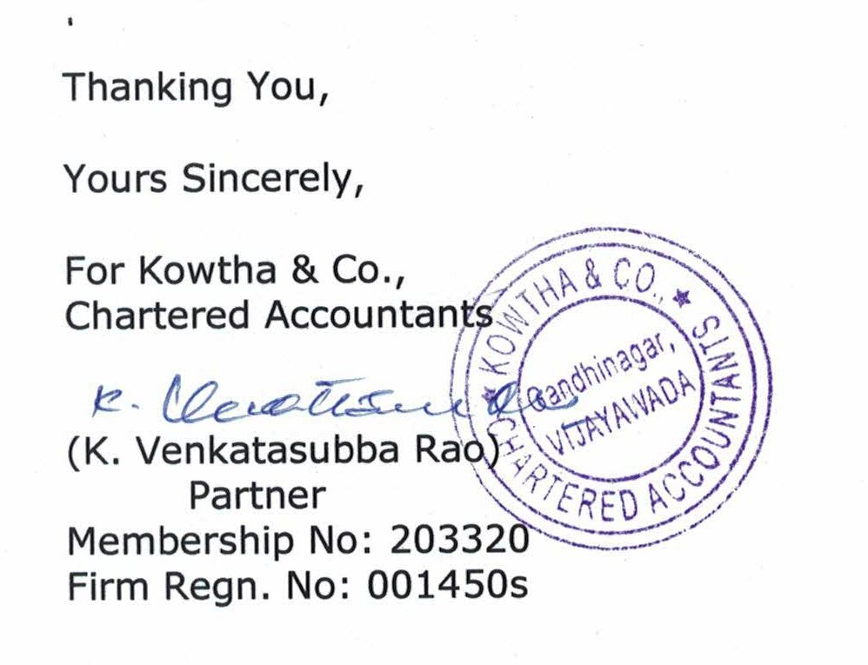

Business Photos:

